Pendulum: Where does your strength come from?
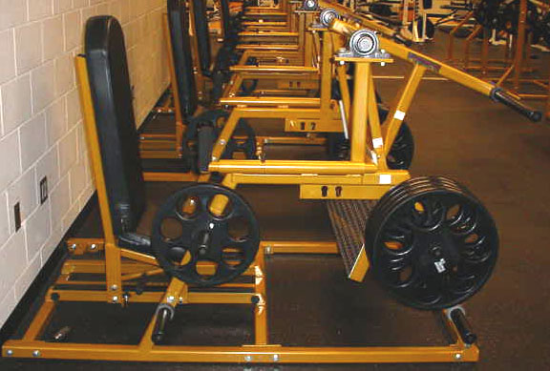
The true goals of a properly designed strength training program should be to increase the muscle structures of the body, increase the overall systemic work capacity, and at the same time minimize the athletes’ risk of injury. With adequate rest, sound nutrition, and proper progression, muscular strength and growth can occur over time. Athletes and trainees can increase strength through a variety of means such as exercise, weight machines, dumbbells, chains, bands, etc. All of these are merely tools to stimulate the muscles in order to produce the desired growth effect, however all exercise tools are not built the same.
Traditional exercise machines may isolate or target a muscle or provide proper overload, but few do it to the extent of the machines made by Tyler Hobson and Pendulum Strength Training Solutions. Most weight machines provide some stimulus to the target muscle, but a majority of them are very poorly designed, putting tremendous stress and shearing forces on weaker joints and tendons. Over time this can hinder an athlete’s performance and lead to permanent injury. With most exercise machines, resistance curves are built to match the strength curve of a muscle for a given exercise. Instead of targeting the major muscle involved in the movement, these machines overload the weaker muscles, and provide poor stimulus to the larger, more powerful structures. A good example of this is a typical Chest Press machine. Most current exercise machines that strengthen the pectoral muscles also provide stimulus to both the deltoids and the triceps musculature as well. The problem common with these chest machines is the tremendous overload of the muscles associated with the shoulder girdle. Over time, through repetitions and overload, this area becomes weaker which can lead to aggravation of the delicate shoulder musculature and permanent damage over time. Also, with most standard machines, as the pectoral muscles fatigue, the weaker triceps muscles fatigue faster and become the limiting factor in continuing the exercise. The exercise set is terminated early due to inadequate triceps strength and subpar chest stimulation.
ENTER PENDULUM
On the Pendulum Chest Press the exact opposite effect occurs. Tyler built his strength curve to fully fatigue the pectoral muscles first, making the triceps the secondary limiting factor. His machine provides the pectoral muscles with a much deeper stimulation and a greater muscle pump. The machine also provides virtually no stress or shearing forces to the delicate shoulder girdle. The Pendulum Chest Press has redefined powerful chest stimulation. One rep is worth a thousand words!
Pendulum’s unique equipment designs are not just limited to the chest press. The transcend all of their strength pieces and make them the most bio-mechanically sound strength equipment on the market today. Another great example is the Hip Press, which has been heralded as the greatest Leg Press machine in the world. Standard Leg Press machines do not compare to this ingenious machine. Typical Leg Press machines overload the quadriceps muscles while providing very little stimulation to the more powerful gluteus muscles. If the hips and glutes are involved in the pressing movement, it is usually at the expense of the lower back or pelvic girdle. Most standard Leg Press machines put a tremendous strain on the lower back region, the pelvic girdle, and the spine, which can lead to lower back strains, hip pain, and eventually a ruptured disc. Unlike traditional machines, the Pendulum Hip Press provides direct stimulation to the gluteus muscles and the hip area (hence the name Hip Press), and because of the unique strength curve, the secondary fatiguing factor becomes the quadriceps muscles in the front of the thighs. All of this is done with no compression to the spine, zero shearing forces to the knee, and no strain to the delicate lower back region.
Not only is Pendulum bio-mechanically superior to any strength equipment available today, it is also built like no other. Tyler uses eleven-gauge steel for all his frames, complete welds where other manufacturers bolt, higher-grade bearings, stainless steel handles, and lock limiters. This equipment is built like a tank and will last a lifetime. One would be hard pressed to find better-built equipment anywhere in the world. Each Pendulum piece is unique. While the hip press uses a large amount of gluteus involvement, it results in no compression to the spine. These positive results are paralleled in the chest press by achieving chest stimulation without any shearing of the delicate shoulder girdle. The Delt Pro uses a unique strength curve to create rehabilitative qualities. The Squat Pro is the world’s finest variable resistance squatting apparatus ever designed. The Forearm Gripper with its unique foot pedal provides for greater strength development and negative accentuated exercise. The newest addition to the line, the Lat Pulldown, with its unique docking mechanism is built to maximize stimulus to the upper back muscles. Each piece is uniquely designed, bio-mechanically and functionally sound, and built to last a lifetime.
Pendulum is the new evolution in strength training!
Houston Chronicle article on Tyler Hobson
Pendulum's Squat Pro - Randy Roach

